Deployment on Flask

Name, Batch code: [LISUM10: 30](https://canvas.instructure.com/courses/4851447)

 Submission date: 04/07/2022

Submitted to : Data Glacier

Done by: Shaimaa Al-khawlani

**Snapshot of each step of deployment:**

1. **Download toy data.**

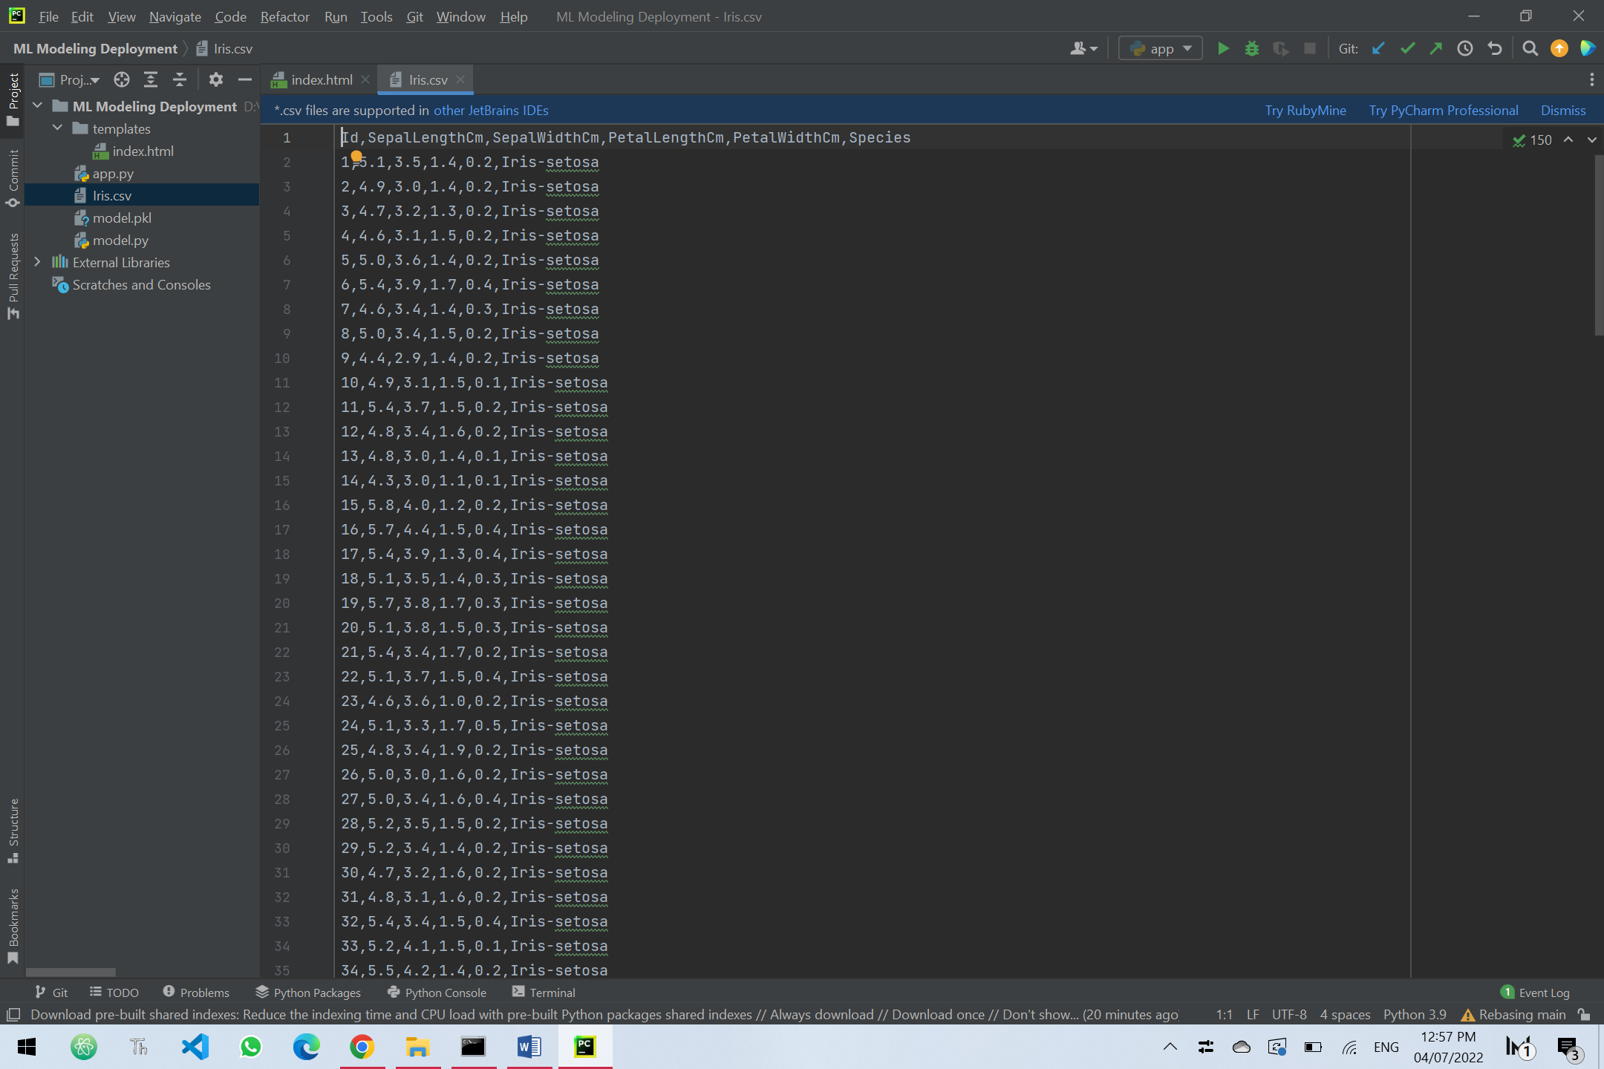

1. **Create HTML index page which contains the input texts of each feature in the toy data.**

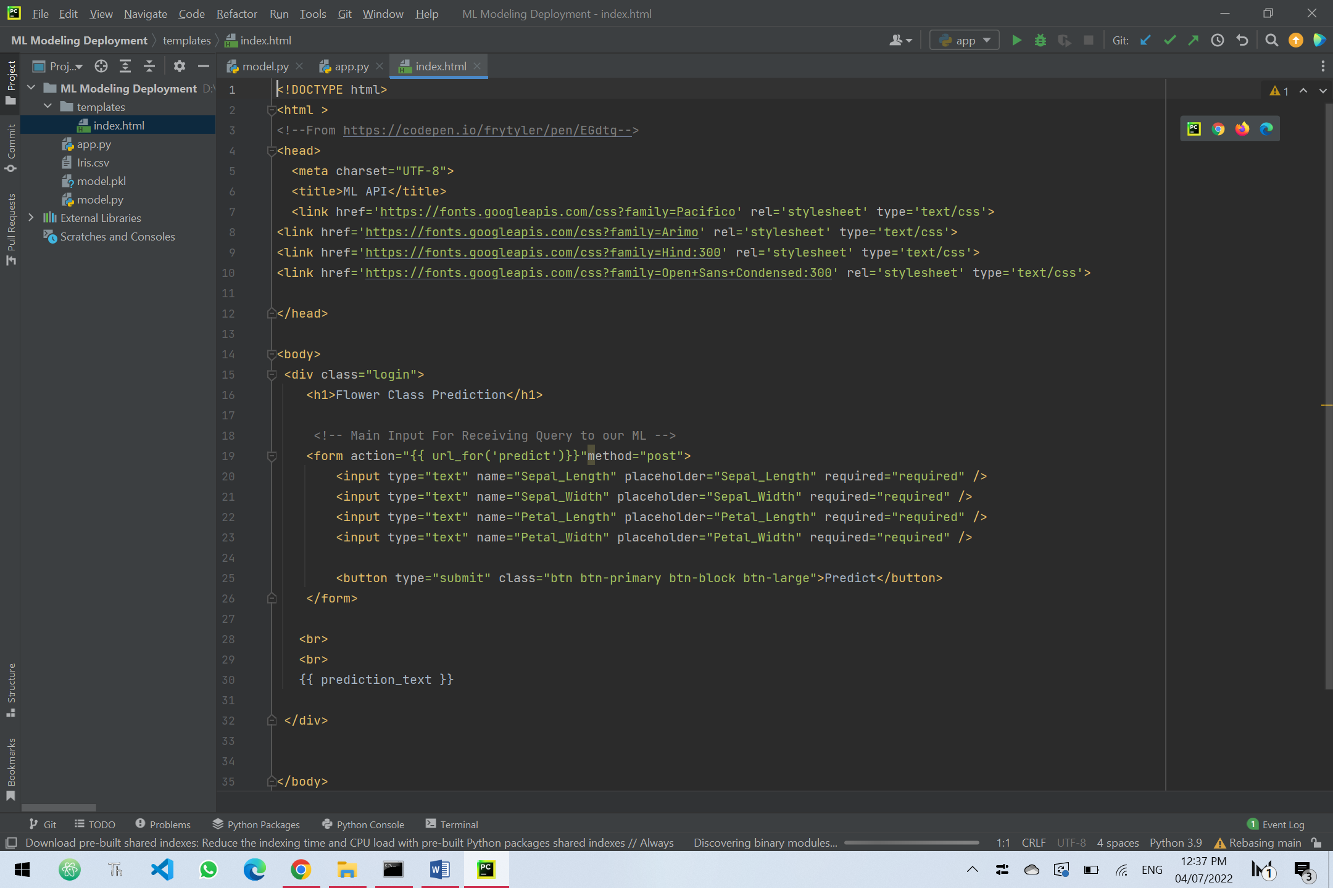

1. **Create the model.py**

* **Read CSV file.**
* **Select independent and dependent variables.**
* **Split dataset into train and test**
* **Feature scaling.**
* **Instantiate the model.**
* **Fit the model**
* **Create pickle file.**

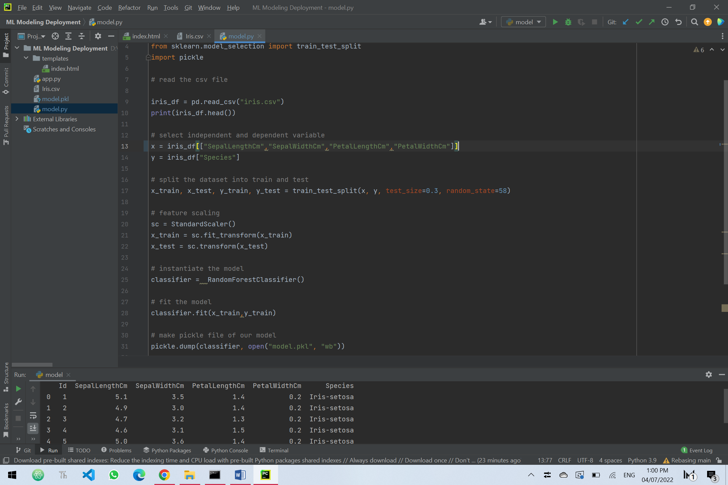

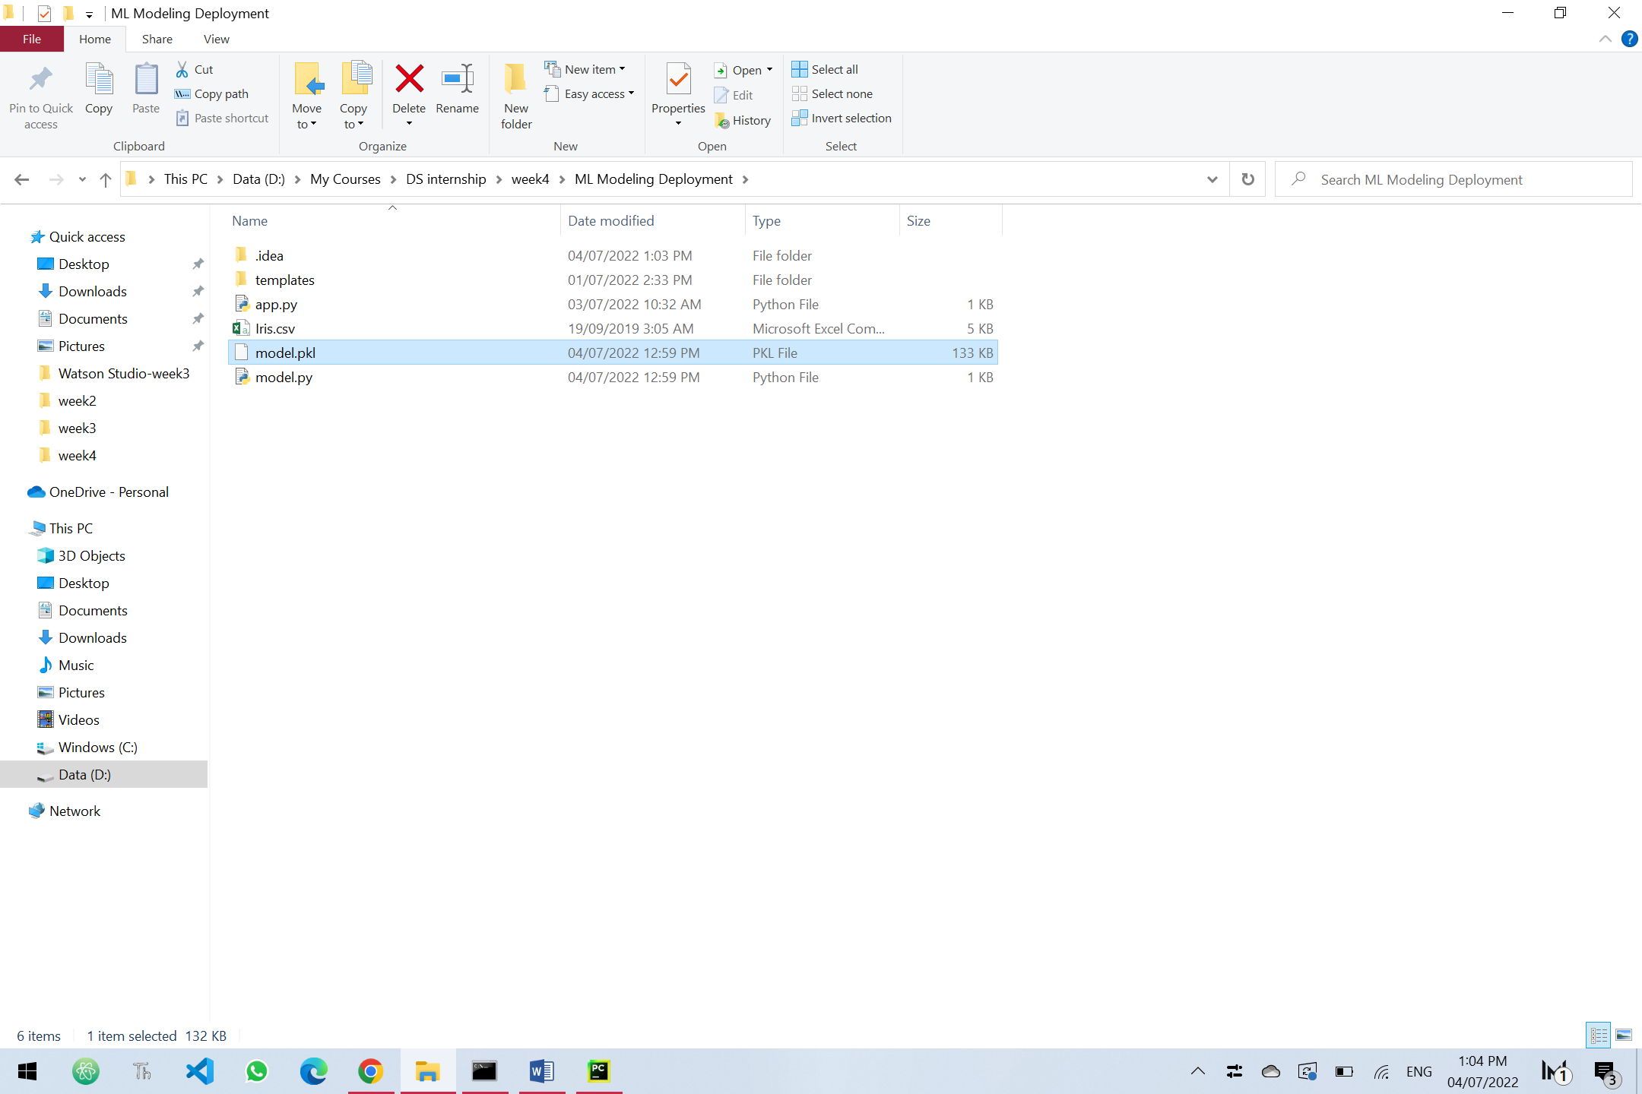

1. **Create app.py**

* **Create flask app**
* **Load pickle model**

